Affordable & Competent Courses | iNeuron.ai

**E-Commerce Dashboard**

**High Level Design (HLD)**

**Nikki Mittal**

Affordable & Competent Courses | iNeuron.ai

**DOCUMENT VERSION CONTROL**

|  |  |  |  |
| --- | --- | --- | --- |
| **Date Issued** | **Version** | **Description** | **Author** |
| **10th January, 2023** | 1.0 | First Version of Complete HLD | Nikki Mittal |
|  |  |  |  |

Affordable & Competent Courses | iNeuron.ai

**ABSTRACT**

E-commerce, often known as electronic commerce, is the exchange of goods and services as well as the sending of money and data through an electronic network, most commonly the internet. These Business-to-Business (B2B), Business-to-Consumer (B2C), Consumer-to-Consumer (C2C), or Consumer-to-Business (C2B) transactions are all possible.

E-commerce analytics is the practise of compiling information from every source that affects the store. Then, this information is used to understand changes in consumer behaviour and emerging online retail trends. Insights from the data will allow to make better informed choices, which should lead to an increase in online sales. A comprehensive range of KPIs related to the entire customer journey, including discovery, acquisition, conversion, retention, and advocacy, can be included in e-commerce analytics. Examining the sales results for each of the products under a certain category helps to understand the top-selling products.

Dashboards help the company to analyse the sales and profit trends and give an insight regarding which areas need to be focussed in order to boost the profits.

Affordable & Competent Courses | iNeuron.ai

**CONTENTS**

Document Version Control……………………………………...2

Abstract………………………………………………………….3

1. Introduction…………………………………………….5-6
   1. Why this High-Level Design Document?.....................5
   2. Scope………………………………………………….6
2. General Description………………………………….…...6
   1. Problem Statement……………………….…………...6
   2. Tool Used……………………….………..…………...6
   3. Excel Features Used………………………..................6
3. Design Details…………………………………………..7-9
   1. Functional Architecture…………………………….7-8
   2. Optimization………………………………………..8-9
4. KPIs………………………………………………………9
   1. KPIs (Key Performance Indicators)…………………...9
5. Deployment……………………………………………...10

Affordable & Competent Courses | iNeuron.ai

1. **Introduction**
   1. **Why this High-Level Design Document?**

The goal of this High-Level Design (HLD) Document is to provide the current project description with the additional depth needed to describe an appropriate model for coding. This paper can be used as a reference guide for how the modules interact at a high level and is also meant to aid in identifying conflicts before coding.

The HLD will:

* Describe each aspect of the design in depth.
* Include design features and the project's architecture.
* Describe the user interface being implemented, hardware and software interfaces, and performance requirements.
* List and describe any non-functional characteristics such as security and reliability.
* Maintenance
* Mobility
* Resource use
* Application compatibility
* Reusability
* Serviceability

Affordable & Competent Courses | iNeuron.ai

* 1. **Scope**

The HLD documentation outlines the system's architecture, including the technology architecture, application architecture (layers), application flow, and database architecture. The HLD employs simple to somewhat complex concepts that system administrators should be able to understand.

1. **General Description**
   1. **Problem Statement**

An online e-commerce company's analytics team wants to create a sales dashboard to evaluate sales based on different product categories. The business aims to provide people more choice over product categories so they may choose one and can observe the trend month- and product-wise as appropriate.

* 1. **Tool Used**

Microsoft Excel is used to design the dashboard to gain insights about the sales and profits trends of the company.

**Source:** [**https://commons.wikimedia.org/wiki/File:Microsoft_Office_Excel_%282019%E2%80%93present%29.svg**](https://commons.wikimedia.org/wiki/File:Microsoft_Office_Excel_%282019%E2%80%93present%29.svg)

Affordable & Competent Courses | iNeuron.ai

1. **Design Details**
   1. 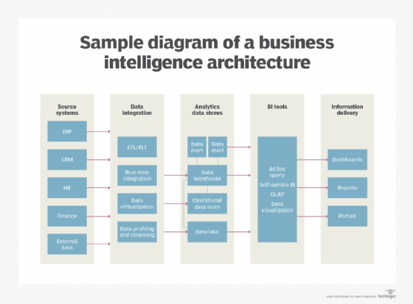**Functional Architecture**

**Source:**

[**https://www.techtarget.com/searchbusinessanalytics/definition/business-intelligence-architecture**](https://www.techtarget.com/searchbusinessanalytics/definition/business-intelligence-architecture)

Affordable & Competent Courses | iNeuron.ai

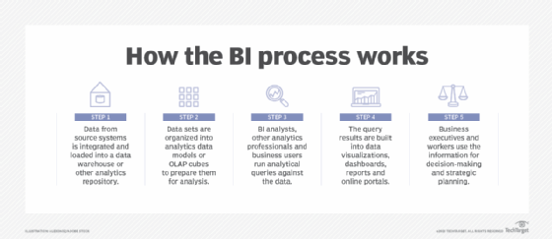

**Source: https://www.techtarget.com/searchbusinessanalytics/definition/business-intelligence-BI**

* 1. **Optimization**

Goal-seeking analysis for one or more variables under certain restrictions includes optimization analysis, which is a more complicated component. Even there is power to modify the restrictions and manage the optimization procedure, it could sound quite difficult. However, Solver was launched by Microsoft Excel to make such optimization analysis simpler.

Affordable & Competent Courses | iNeuron.ai

The What-if analysis tool known as Excel Solver has a unique collection of commands. In many commercial and engineering models, it serves as a simulation and an optimization tool.

The finest tool for optimization with constraints is Excel Solver. It aids in calculating the return on investments, ideal budget, production costs, labour scheduling, and many other things.

1. **KPIs**

Dashboard will be used to display and highlight KPI and important factors affecting the sales and profits. Dashboards will be incorporated as soon as the system begins collecting historical or regular data for a user in order to show progress on various indicators or factors over time.

* 1. **Key Performance Indicators**

In the dashboard, the following indicators have been used:

* Sales
* Quantity
* Profit

Affordable & Competent Courses | iNeuron.ai

1. **Deployment**

Whatever strategy is chosen to grow the e-commerce business, there are certain activities and actions that must be performed. The e-commerce business can be boosted by taking important steps like accounting, sales tracking, scheduling, marketing, and reaching a larger target audience and these may be completed by designing dashboard corresponding to the business data in Microsoft Excel which can help generate useful insights for the business.